EudraCT – Work Instruction

This document describes the steps required to upload the AE/SAE data to the EudraCT system, using an automated process, as required by the trial statistician. Note, that if only a few AE/SAEs are reported on your trial it may be easier to input data manually.

The document is split into four different sections; obtaining the data, creating the formats library, checking the data and uploading the data. Each section should be completed in turn and any issues dealt with prior to moving onto the next section.

Definitions of what data is to be uploaded is beyond the scope of this document. The statistician should initially log into EudraCT and see the AE section to become familiar with what data is required for the Adverse Event upload as follows:

1. Go to <https://eudract.ema.europa.eu/> and click Login to EudraCT.

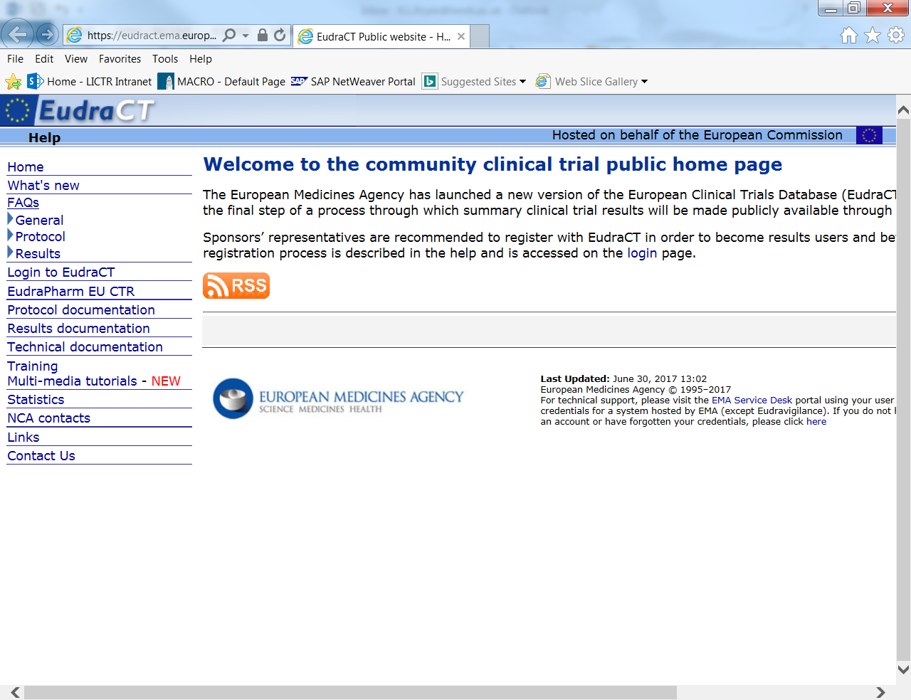

1. Login using your specific trial login. 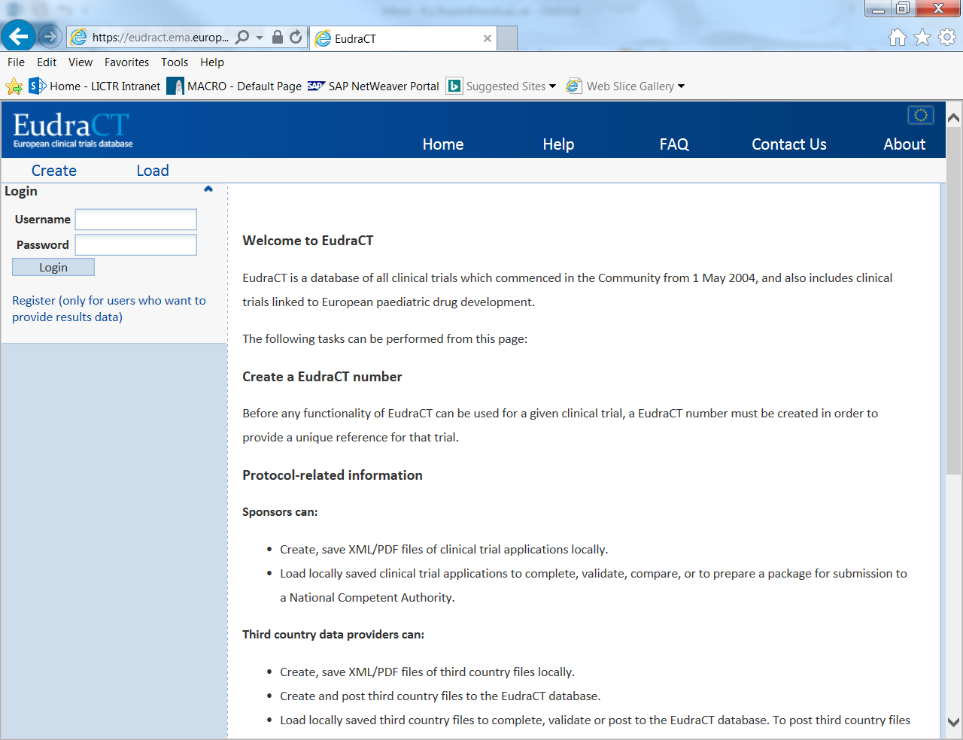
2. Click edit on the relevant trial

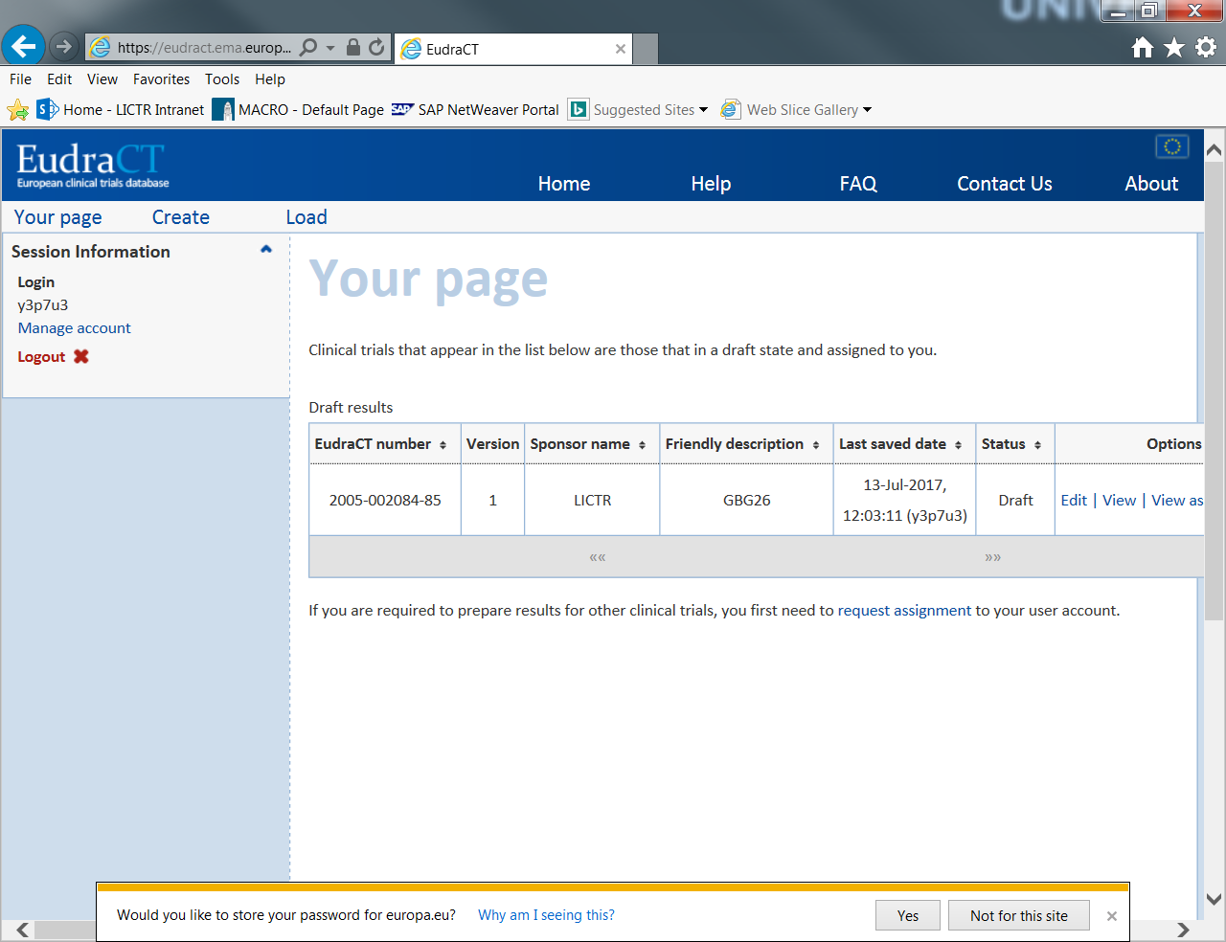

1. Click on Adverse events

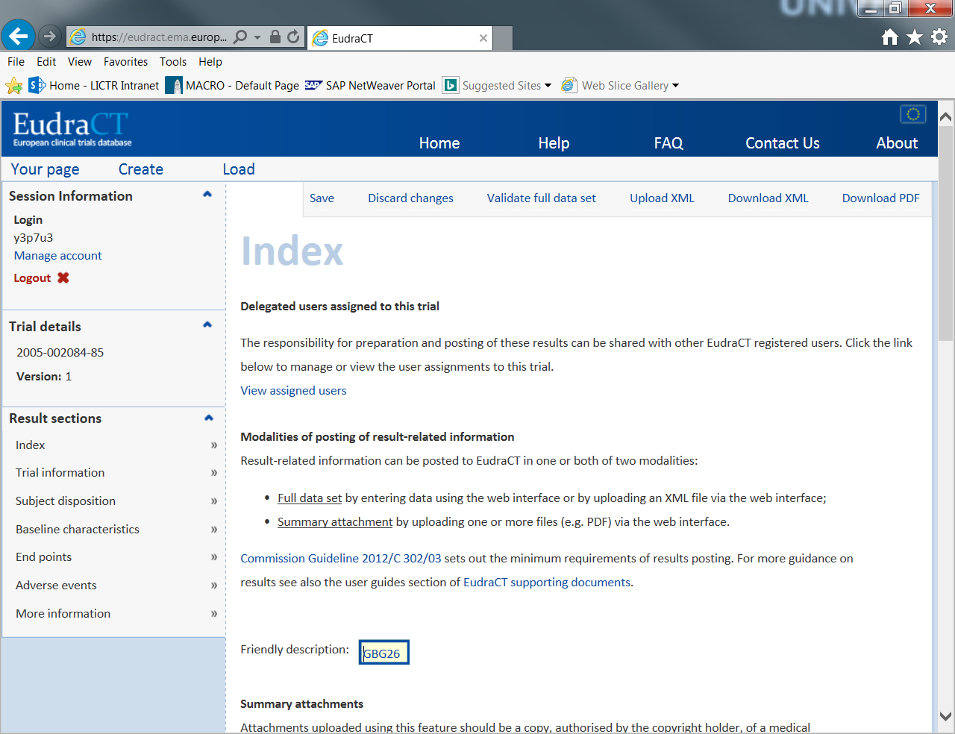

The programs for the following sections can be found here: P:\CTRU\Stats\Programming\SAS\Eudract\EudraCT_Upload_V1.0

Note that the process does not allow different medical dictionaries for individual terms, one overall dictionary is required. Furthermore the process has been fully validated for CTCAE V4.0/27th MedDRA SOC terms (See Part C point V.).

*Part A: Getting the datasets into the correct form*

Whilst the definitions of each variable may differ on a trial by trial basis, the overall process requires three datasets, which include the mandatory variables in a specific form and correspond to specific fields on the EudraCT system.

EudractGrps – Adverse Event Reporting Groups (safety statistics by reporting group)

|  |  |  |  |
| --- | --- | --- | --- |
| **Variable Name** | **Mandatory?** | **Description** | **Attributes** |
| idn | Y | Identification number for reporting group | Numeric |
| id | Y | Text identification for reporting group | Text (Length = 62) |
| desc | N | Description of reporting group | Text (Length = 999) |
| patn | Y | Number of patients in reporting group that safety information reported – i.e the number in the safety population | Numeric |
| patae | Y | Number of patients reporting at least 1 adverse event in reporting group | Numeric |
| Patsae | Y | Number of patients experiencing at least 1 serious adverse event | Numeric |
| death | Y | Number of deaths in reporting group | Numeric |
| deathae | N | Number of drug-related deaths | Numeric |

* EudractSAE – Summaries of SAEs by reporting groups (if an SAE occurred in one group but not another then it needs to be included as zero)

|  |  |  |  |
| --- | --- | --- | --- |
| **Variable Name** | **Mandatory?** | **Description** | **Attributes** |
| idn | Y | Identification number for reporting group should match to above. | Numeric |
| SOC | Y | MEDDRA system organ class for SAE. | Text (Length=100) |
| Term | Y | SAE term. | Text (Length=100) |
| desc | N | Additional description. | Text (Length=250) |
| Asstype | Y | Assessment type (1=Systematic, 2=Non-Systematic). | Numeric |
| patsn | Y | Number of patients experiencing event. | Numeric |
| occur | Y | Number of occurrences of event. | Numeric |
| occurtrt | Y | Number of occurrences caused by treatment. | Numeric |
| death | Y | Number of deaths for event. | Numeric |
| deathtrt | Y | Number of deaths due to treatment. | Numeric |

* EudractAE - Summaries of AEs by reporting groups (if an AE occurred in one group but not another then it needs to be included as zero)

|  |  |  |  |
| --- | --- | --- | --- |
| **Variable Name** | **Mandatory?** | **Description** | **Attributes** |
| idn | Y | Identification number for reporting group should match to above. | Numeric |
| SOC | Y | MEDDRA system organ class for SAE. | Text (Length=100) |
| Term | Y | SAE term. | Text (Length=100) |
| desc | N | Additional description. | Text (Length=250) |
| Asstype | Y | Assessment type (1=Systematic, 2=Non-Systematic). | Numeric |
| patsn | Y | Number of patients experiencing event. | Numeric |
| occur | Y | Number of occurrences of event. | Numeric |

The following points should also be considered:

* If AEs are not reported on the trial an empty dataset still needs to be created:

**data** EudractAE;

length soc $**100** term $**100** desc $**250**;

call missing(idn,soc,term,desc,Asstype,patsn,occur);

if _N_ = **0** then output;

stop;

**run**;

* On the EudraCT system there is a large free-text section, which is **not** covered by these programs, to describe the AE timeframe for reporting and also the assessment type. Here you should state:
  + How often AEs are collected and whether for example only ARs are collected.
  + Define how the field ‘occurrences’ has been defined.
  + Define the cut-off percentage for reporting AEs/SAEs, a maximum of >5% patients is permitted.

*Part B: Obtaining the formats library*

*The EudraCT system requires that free text SOC terms defined in the* EudractAE and EudractSAE datasets *are uploaded as a formatted variable. This step allows formats to be applied in the upload process.*

1. Copy the file P:\CTRU\Stats\Programming\SAS\Eudract\EudraCT_Upload_V1.0\EUTCT_formats_V22.sas into your trials EudraCT directory.
2. Update the header and directories as required.
3. Run the program.
4. Check the log for any issues and to ensure the formats library has been successfully created in the formats library you specified in the program.

*Part C: Checking that your datasets are in the correct form*

1. Copy the file: P:\CTRU\Stats\Programming\SAS\Eudract\EudraCT_Upload_V1.0\ XML_input_checkerV1.0.sas, into your trial’s EudraCT directory.
2. Update the header and directory as required.
3. Update the libname statement for the EudraCT formats library.
4. The program is split into clearly defined different sections for each validation check. Run the program one section at a time and check for errors. If error messages are produced correct the appropriate input dataset (referring back to the dataset specification) before moving onto the next section.
5. If SOC terms are not matching to the Eutct formats because you believe the set of SOC terms defined in the formats are using a different version of the dictionary to the that defined in your trial the formats version may need updating and re-validating. To do this please refer to: P:\CTRU\Stats\Programming\SAS\Eudract\EudraCT_FormatsValidation\README V1.0.
6. The program should be run in its entirety without errors prior to moving onto the next section.

*Part D: Creating the XML file*

1. Copy the file: P:\CTRU\Stats\Programming\SAS\Eudract\EudraCT_Upload_V1.0\XML_creator_V1.0.sas into your trial’s EudraCT directory.
2. Update the header, directory, libname statements, file string, sasout string and saslog string as required.
3. Run the program
4. Check that the xml file has been created in the output of the study directory
5. Check the log for errors.

*Part E: Uploading to EudraCT*

*This step describes uploading the XML file to EudraCT. Log into the system and navigate to the Adverse event page as described at the beginning of this document.*

1. Click on “Upload XML”

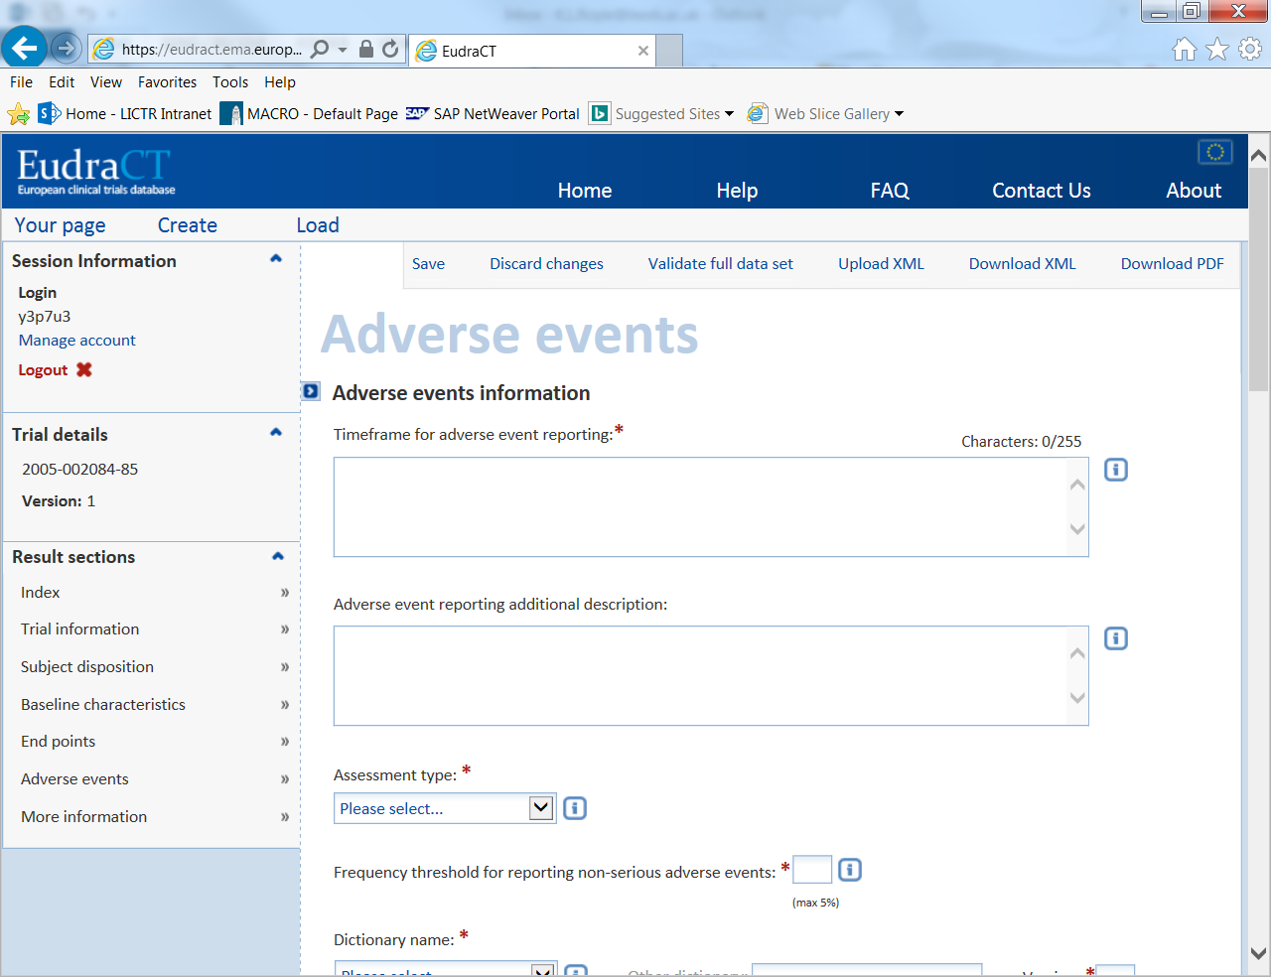

1. Click confirm

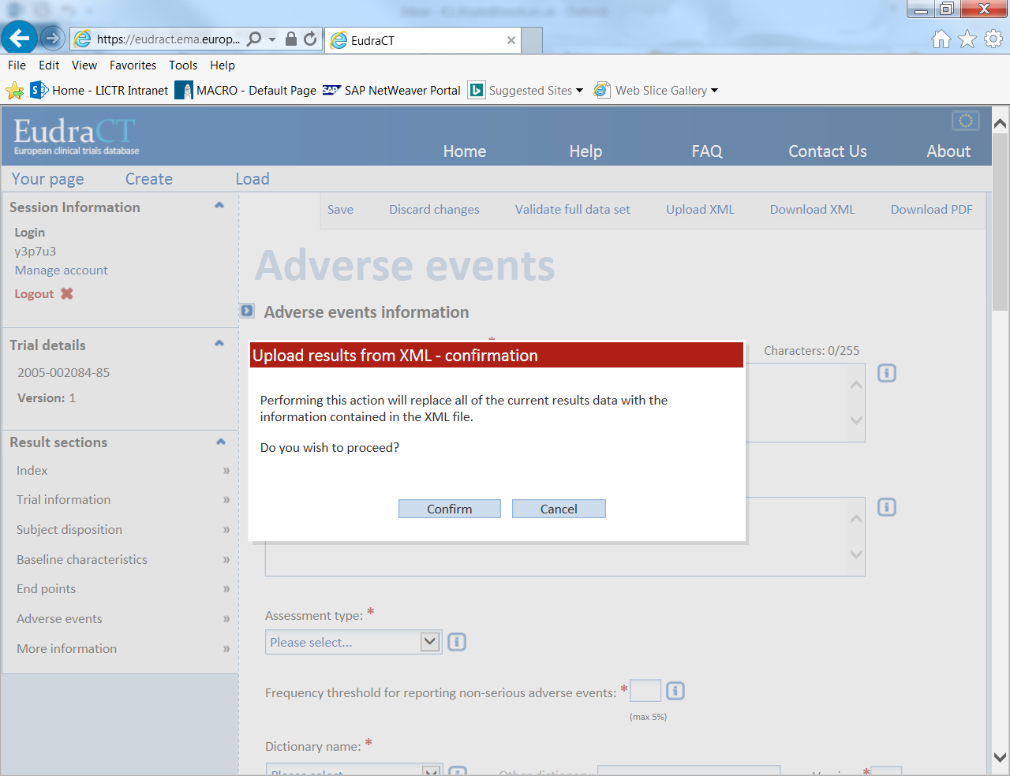

1. Change the type of file to “Adverse Events” and click +Add…

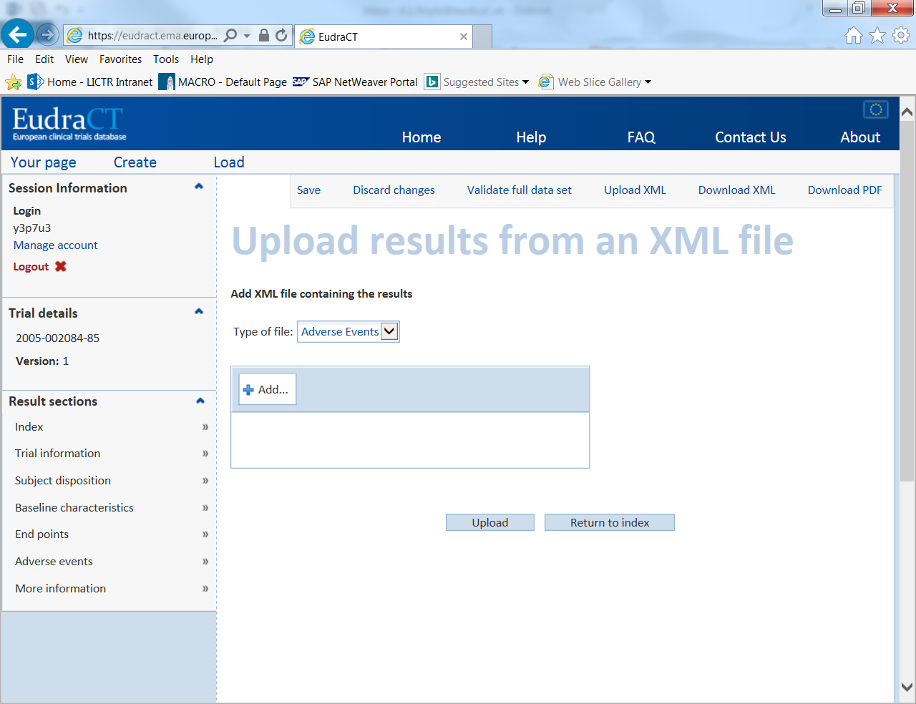

1. Find your outputted XML file and click open.

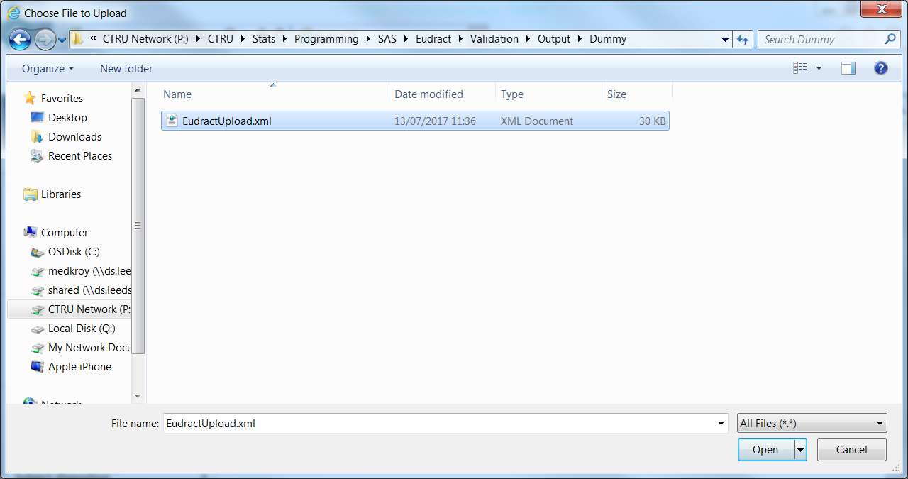

1. Click upload

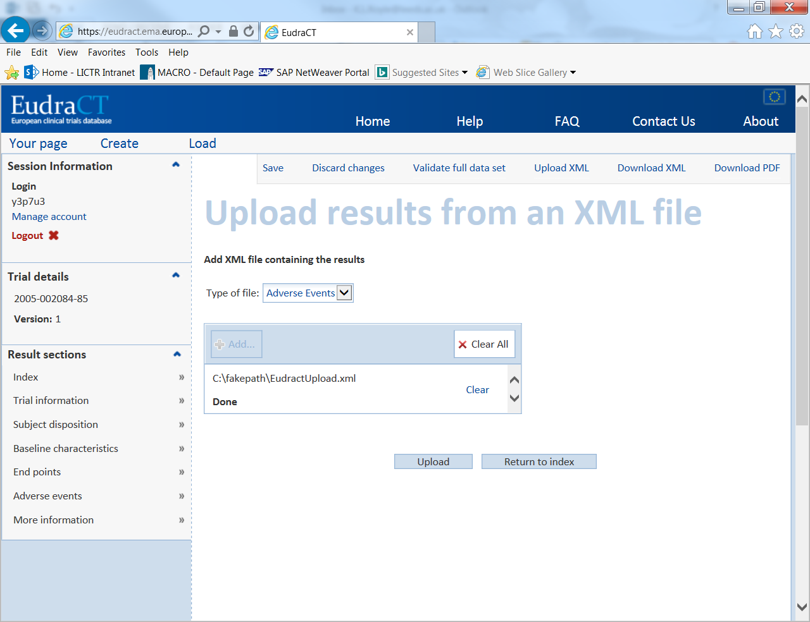

1. If successful you should get the following message, click ok.

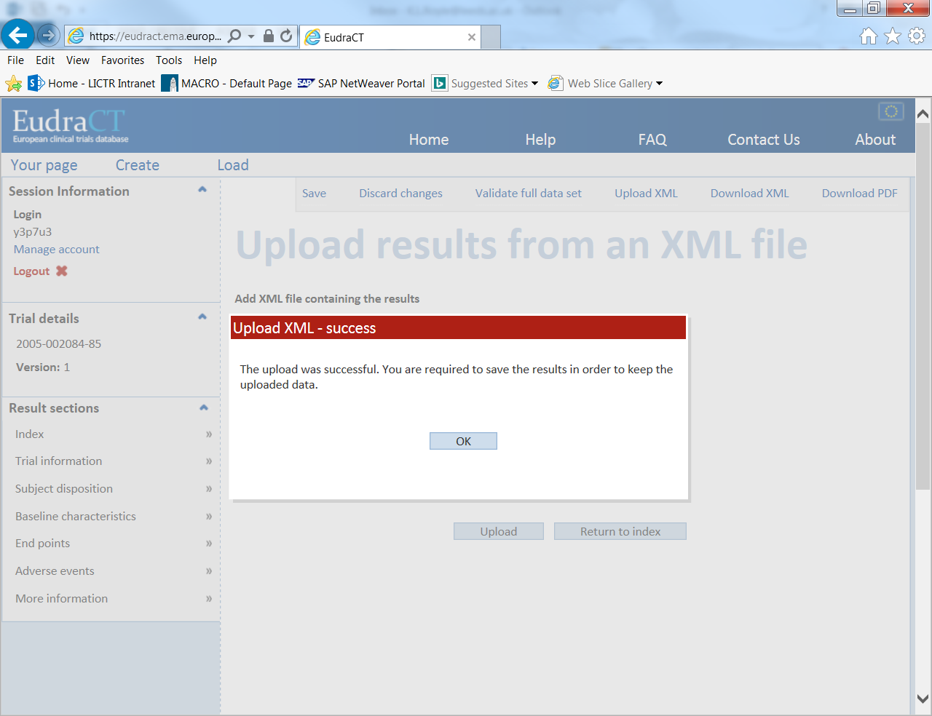

1. This will take you back to the homepage, click on Adverse events and check that your data has uploaded correctly. For example:

